**Lab Experiment 6**

**USER INTERFACE AND DESIGN**

**Simulating UI Design Lifecycle Using the RAD Model**

**Phase 1: Requirements Planning**

**Elements/Pages:**

* **Home** – a dashboard to highlight deals and popular products
* **Product Lists** – organized by categories like Men, Women, Shoes, Accessories
* **Product Details** – shows product image, name, description, price, and size options
* **Cart** – view selected items with quantity and pricing
* **Checkout** – confirm the order and choose a payment method
* **Order History** – view previously purchased items
* **Profile and Settings** – manage account details and preferences

**Key User Actions:**

* Browsing and filtering products
* Searching for items
* Viewing product details
* Adding items to the cart
* Managing cart contents
* Proceeding through checkout
* Reviewing order history
* Managing user settings

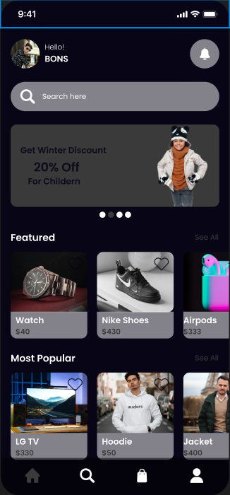

**Phase 2: User Design**

**Tool Setup:**  
We would use Axure RP (or a similar prototyping tool) to build wireframes and make the interface interactive.

**Project Setup:**  
We created a new project called **"Shopping App Interface."**

**Designing the Screens:**  
Based on the image provided, we created wireframes for:

* **Home Page** – featured sections, top deals, categories
* **Product List** – scrollable view of products with category filters
* **Product Details** – zoomed image, size selection, description, and price
* **Cart Page** – items added with total price and quantity options
* **Checkout Page** – delivery details, payment method selection (PayPal, Credit Card, Cash)
* **Order History** – list of previous purchases and their status
* **Profile Page** – user details and profile settings
* **Settings Page** – notification settings, language preferences, and support options
* 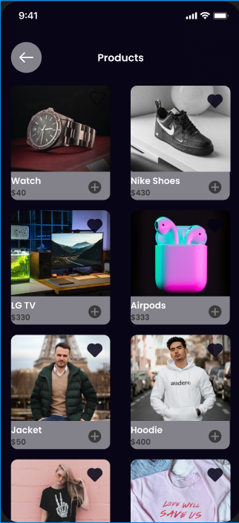 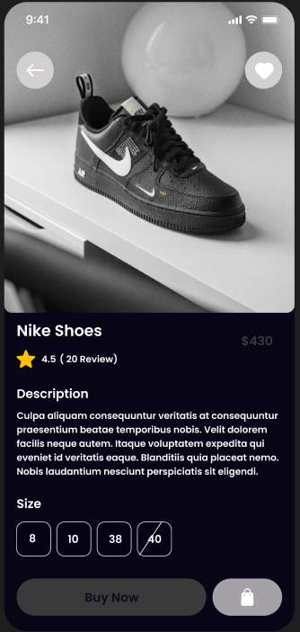

**Adding Interactions:**  
We added basic interactions, such as:

* Clicking a product opens its detailed view
* “Buy Now” adds the item to the cart
* Clicking the cart icon navigates to the cart page
* “Checkout” button leads to the payment screen
* 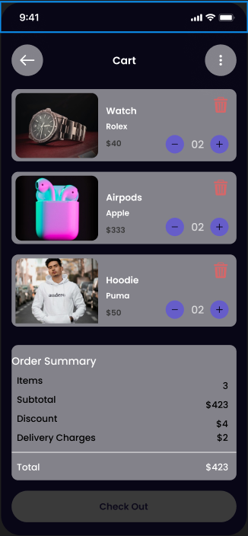 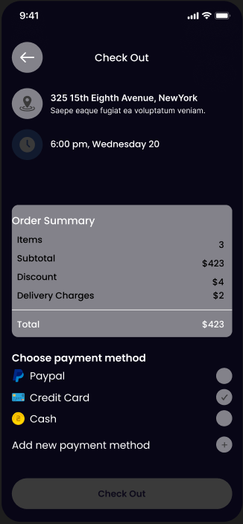

**Reusable Components :**  
To save time and maintain consistency, we created:

* **Header** with logo, cart icon, and profile icon
* **Footer** with navigation buttons (Home, Search, Cart, Profile)

**Annotations:**  
We added notes to each screen describing what it does and how users interact with it, helping future developers or team members understand the design quickly.

**Phase 3: Construction**

**Interactive Prototype:**  
Using Axure’s interaction tools, we linked the screens to simulate a real app experience:

* Dynamic filters for sorting products
* Clickable buttons and links
* Responsive transitions between pages
* Pop-ups and modals (like selecting size or confirming order)
* 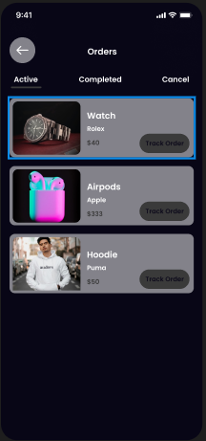 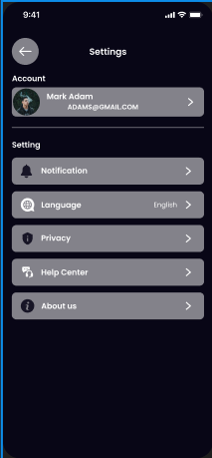

**Testing and Feedback:**  
We tested the prototype internally. Based on user feedback, we improved button visibility, made filter options more accessible, and refined the checkout flow for clarity.

**Phase 4: Cutover**

**Finalizing the Project:**  
After testing and final adjustments, we exported the final prototype as an HTML file and/or uploaded it to Axure Cloud for easy access.

**User Training and Support:**  
We prepared a brief user guide that walks users through key app functions like browsing, filtering, adding items to the cart, and completing the checkout process.